**EXPERIMENT 7**

DQL COMMANDS (COLLEGE SCHEMA)

Aim:

* Display student id and marks from the student table.
* Display faculty id and name from the faculty table.
* Display who got grade A.
* Display whose marks are less than 50.
* Display the female students whose marks are between 50 to 60.
* Delete the failed students.
* Display activity id and name using object.
* Display student id, faculty id using course name condition with object.
* Select department name starting from ‘c’ and faculty name ending with ‘ ’.
* Select activity having characters between ‘s’.
* Group by faculty id and display.
* Display the students list whose grade is A using having.
* Display the faculty list who are teaching DBMS.
* Apply aggregate functions in student marks - max, min, sum, count, avg.

* Display student id and marks from the student table.

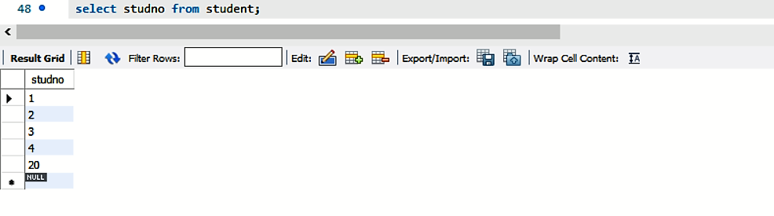

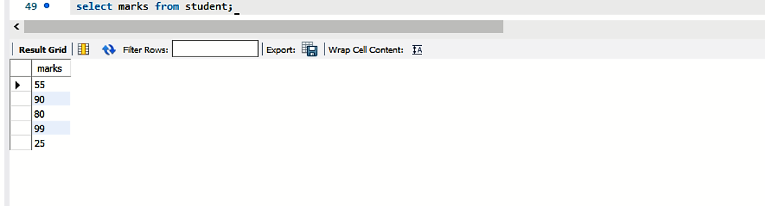

* Display faculty id and name from the faculty table.

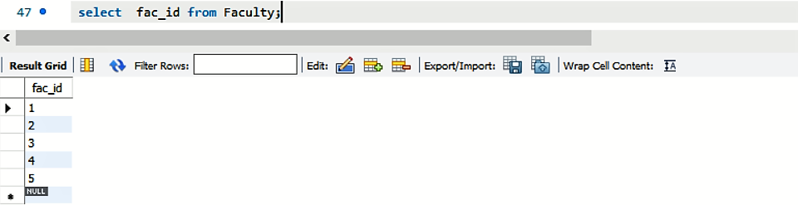

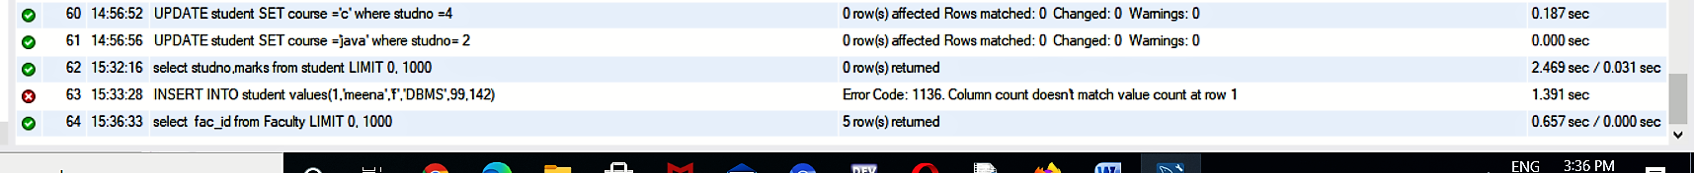

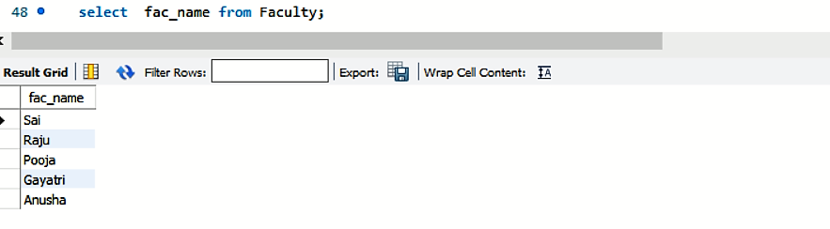



* Display who got grade A

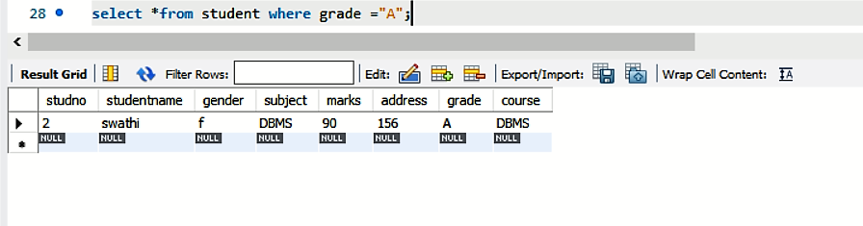

* Display whose marks are less than 50.

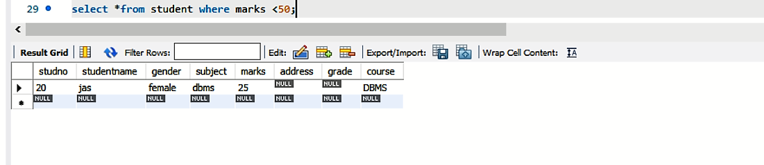

* Display the female students whose marks are between 50 to 60

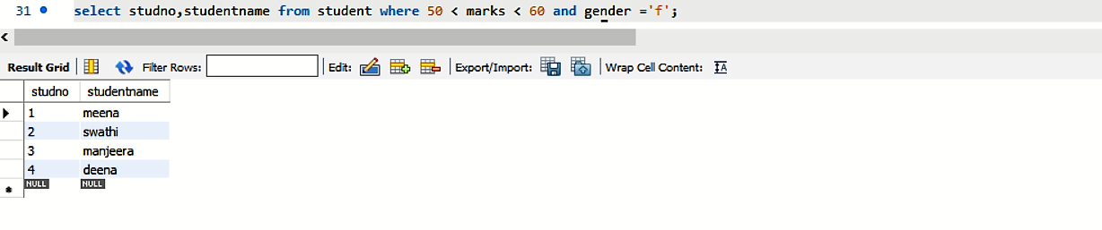

* Delete the failed students.

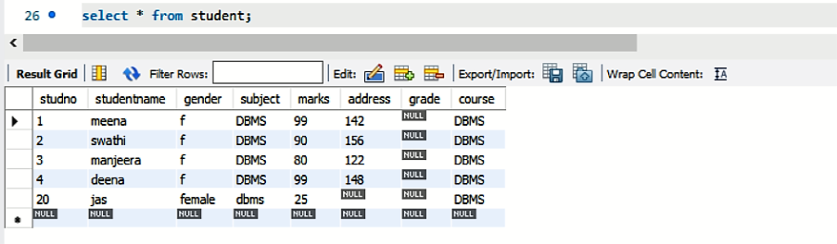

* Select department name starting from ‘c’ and faculty name ending with ‘ ’.



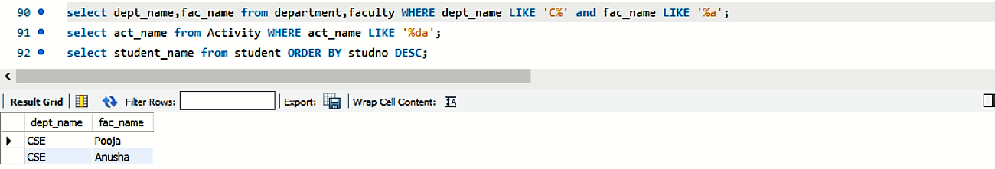

* Select activity having characters between ‘s’.

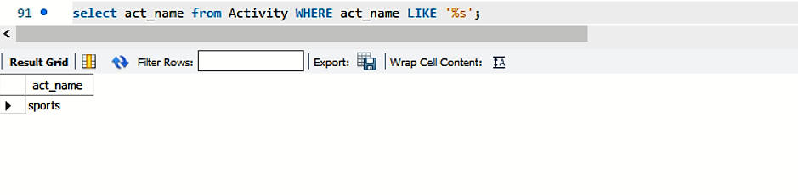

* Group by faculty id and display.

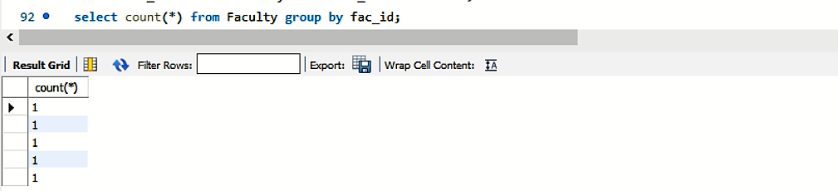

* Display the students list whose grade is A using having.



* Display the faculty list who are teaching DBMS.



* Apply aggregate functions in student marks - max, min, sum, count, avg.

